BIT4133: Natural Language Processing
Logbook Report
Student Name: NDIKUMANA DON DE DIEU. Admission Number: BSCCS/2024/34481
Course/Class:
Unit Code: BIT4133
Unit Name: Natural Language Processing
Lecturer Name:
NYORO MICHAEL
Semester/Year: Sem II ,Year IV
Project Title:
Technologies: Python, NLTK, spaCy, Jupyter Notebook, TensorFlow .
GitHub Repositoryhttps://github.com/cde123-sudo/Natural-language-processing/upload

Table of Contents

Week 1 : NLP Practicals
Practical 1: Text tokenization using python
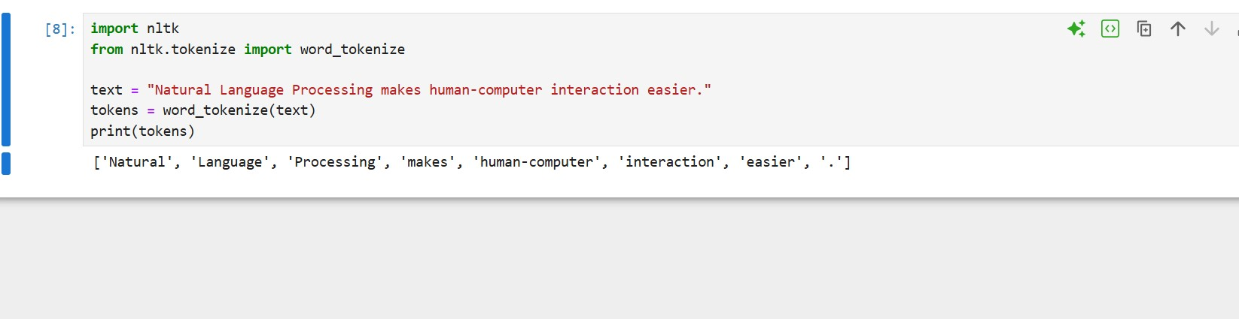
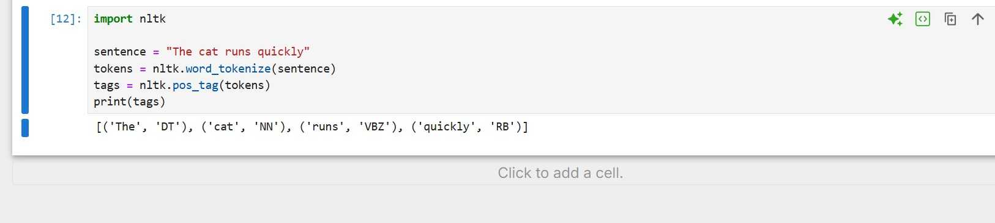
Practical 2: Word Frequency Counter
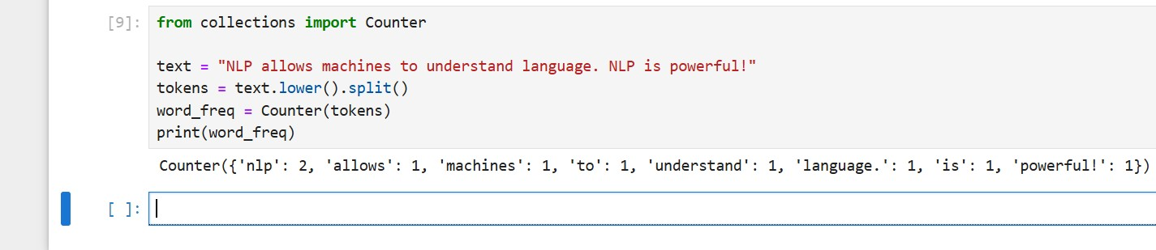
Week 2: Practicals
Practical 1 : POS tagging in python

Week 1: Introduction to NLP and Applications
Fig 1: Python Installation
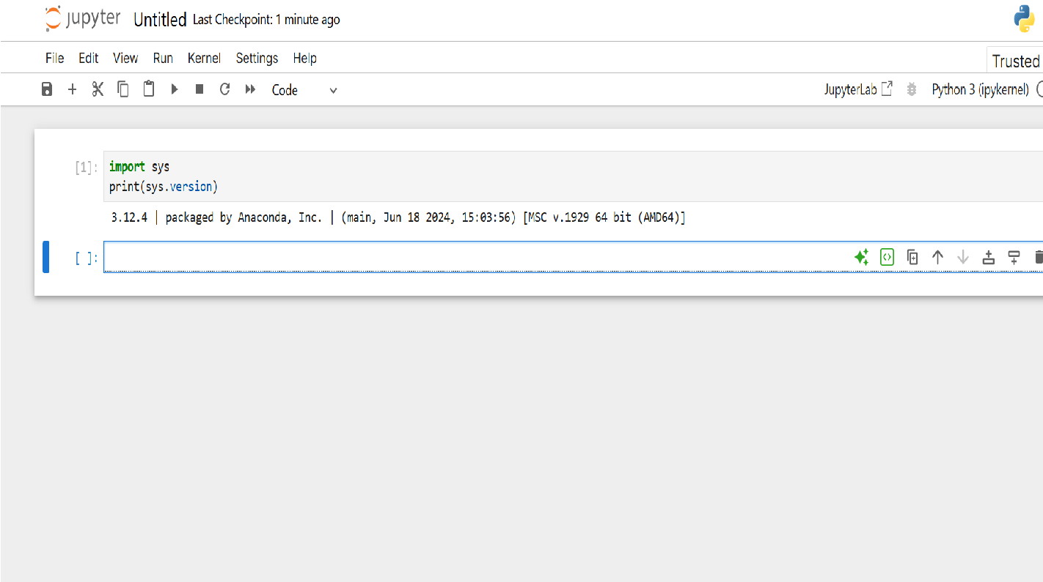
Fig 1 showing Python version confirmation showing the installed Python environment in Jupyter Notebook.
Fig 2: Jupyter Notebook Setup
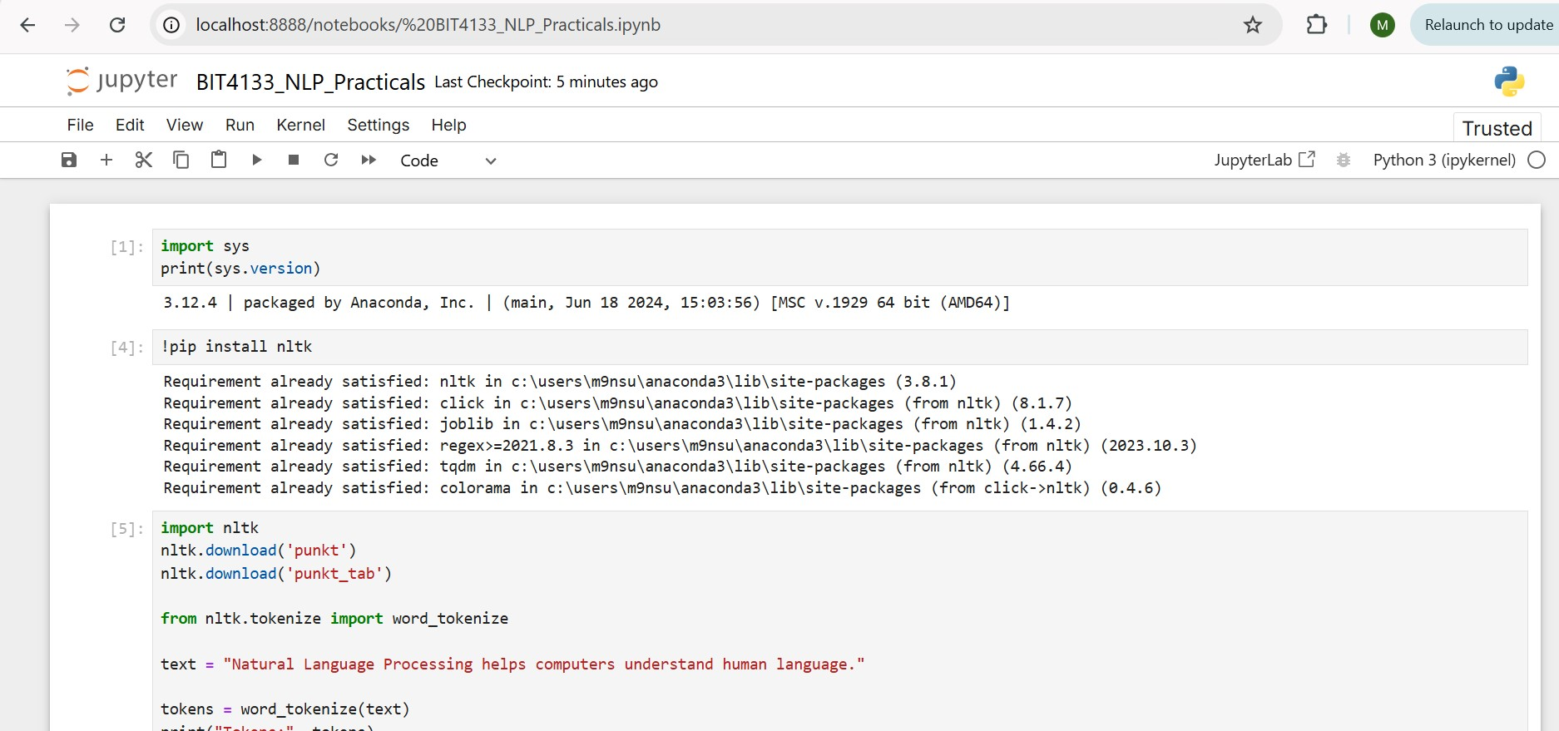
Fig 2 showing Jupyter Notebook environment open with the notebook created.
Fig 3: NLTK Installation
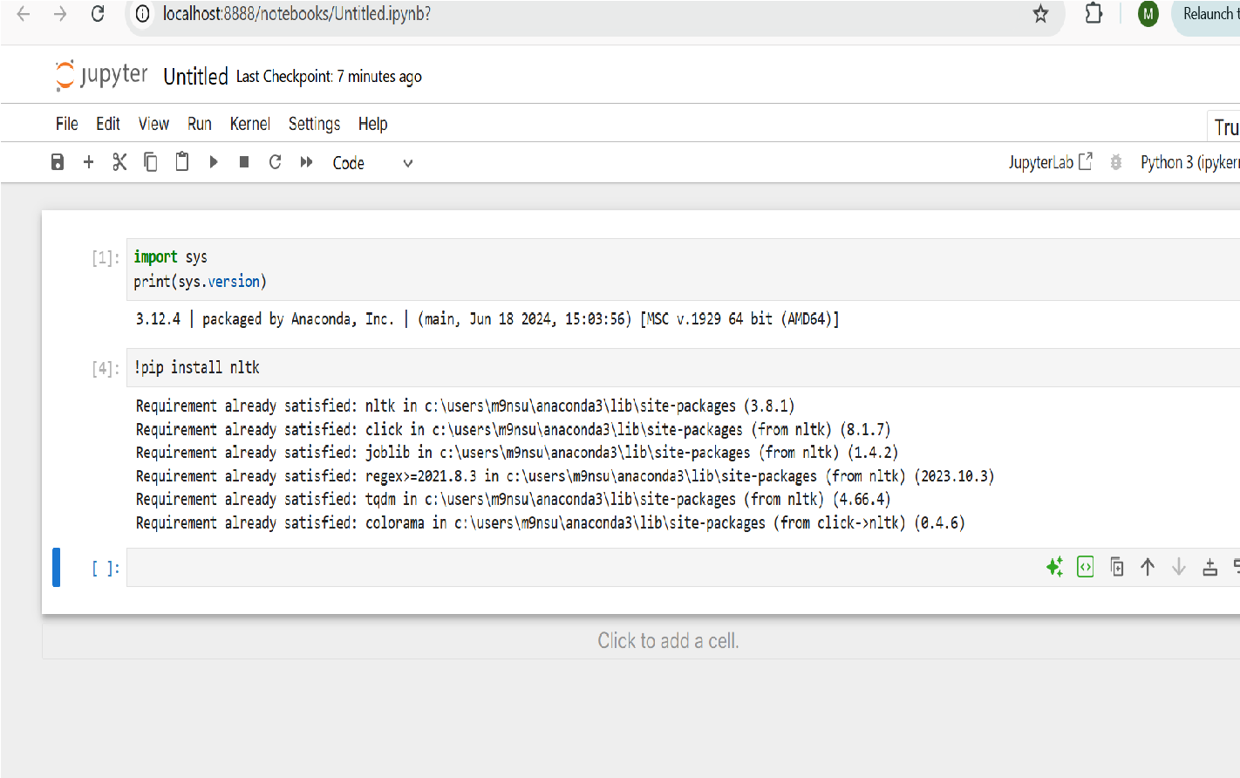
fig 3 showing NLTK library version 3.8.1 confirmed installed via Anaconda package manager.
Fig 4: Tokenization Output
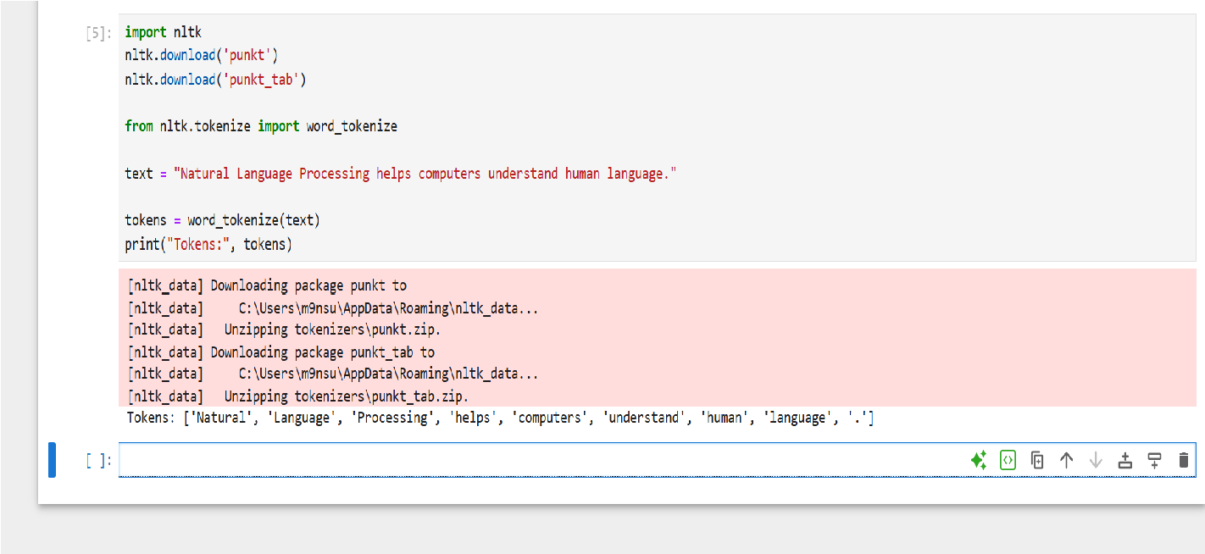
Fig 4 showing Tokenization of an NLP sentence using NLTK word_tokenize(), breaking the text into individual word tokens
Fig 5: Stopwords Removal Output
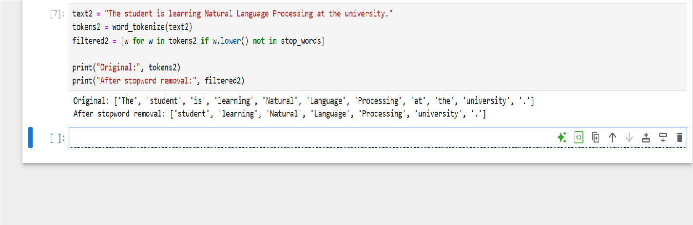
Fig 5 showing Demonstration of stopword removal using NLTK, showing original tokens versus filtered tokens with common words removed. Fig 6: NLP Application Research
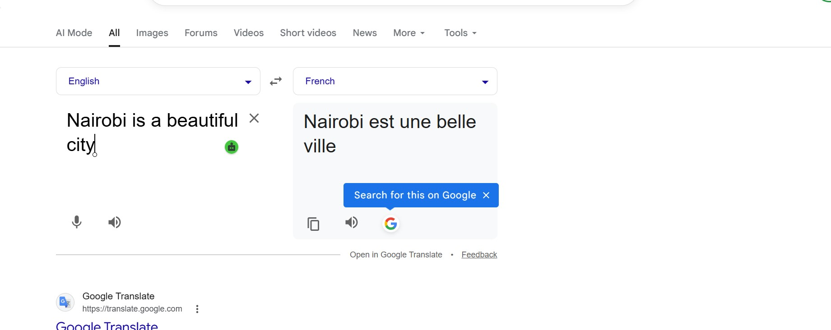
fig 6 shows Google Translate demonstrating NLP application which is machine translation between English and french.
Reflection : This week I set up my NLP development environment by confirming Python and NLTK were already installed via Anaconda on Jupyter Notebook. I ran a tokenization script that successfully broke a sentence into individual word tokens using NLTK's word_tokenize() function. I also performed stopword removal which filtered out common words from the token list, and observed that sentences without common words like 'the' or 'is' remain unchanged after filtering. Finally I researched real world NLP applications and tested Google Translate as an example of machine translation in action. The main challenge was the pip install command hanging in Jupyter which was resolved by importing NLTK directly instead.
Week 2: N-gram Models and POS Tagging

Fig 1: Trigram Output
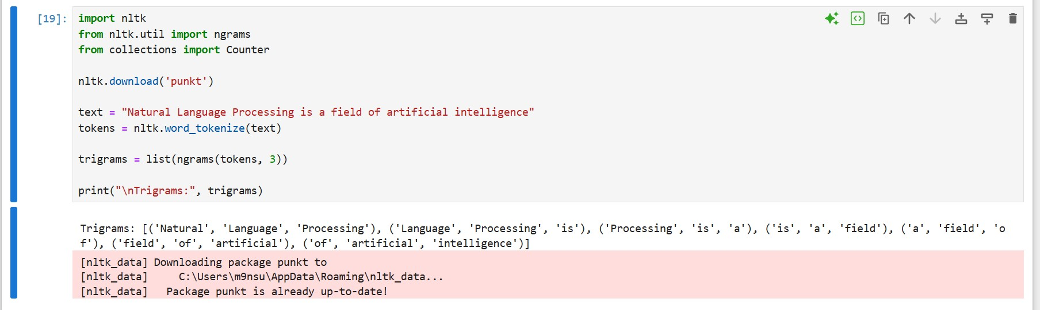
Fig 1: Trigram output generated from a sample NLP sentence using NLTK's ngrams function, showing consecutive word triplets .

Fig 2: POS Tagging Example
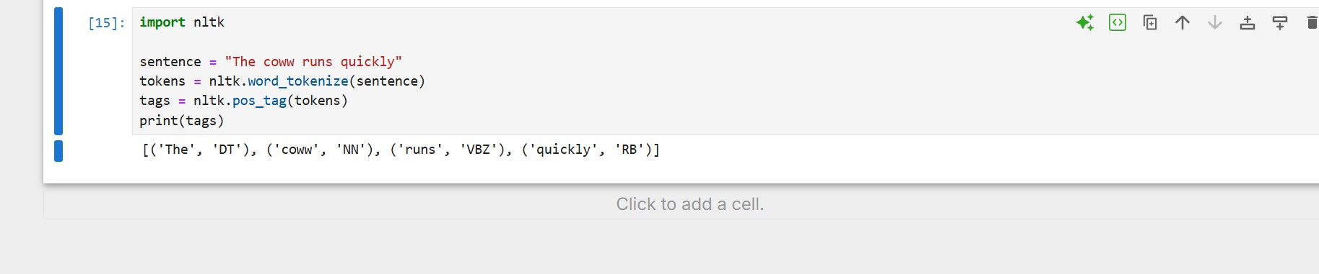
Fig 2: POS tagging output showing each word paired with its grammatical tag including determiner, noun, verb and adverb.

Fig 3: Python Code for POS Tagging
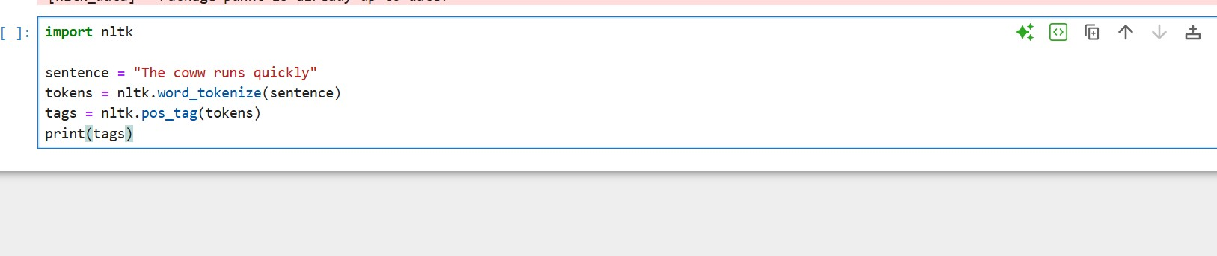
Fig 3: Python code for POS tagging implementation using NLTK's pos_tag() function used in a simple sentence.

Fig 4: Language Prediction Example
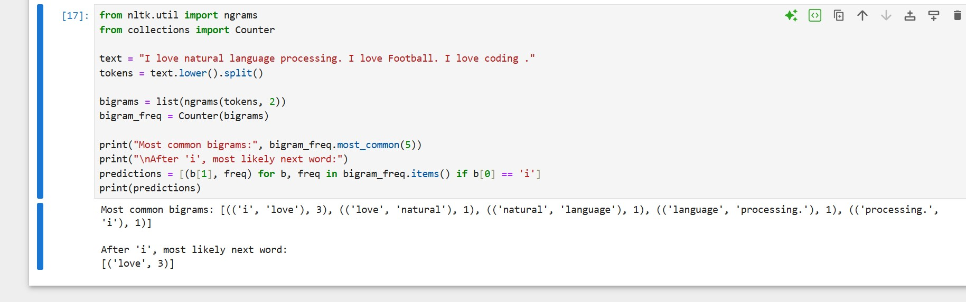
Fig 4: Language prediction example using bigram frequency analysis predicting based on word pair counts.
Fig 5: Sentence Analysis Output
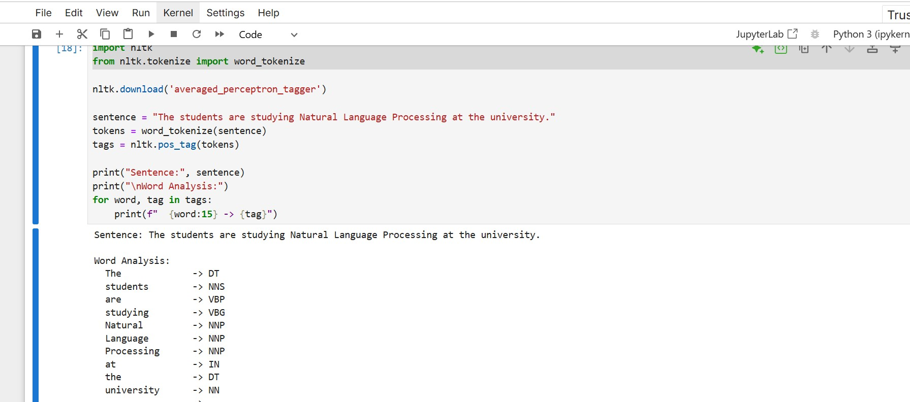
Fig 5: Full sentence analysis output showing a detailed breakdown of a complex sentence using POS tagging.
Reflection:This week I went through N-gram models and Part of Speech tagging using Python and NLTK. I generated bigrams and trigrams from a sentence which showed how consecutive words are paired to model language patterns. I also implemented POS tagging which labels each word in a sentence with its grammatical role . The main challenge I faced was a LookupError for the averaged_perceptron_tagger resource which I resolved by downloading it using nltk.download().
Week 3: Hidden Markov Models and Sequence Labeling

Fig 1: Sequence Labeling Code
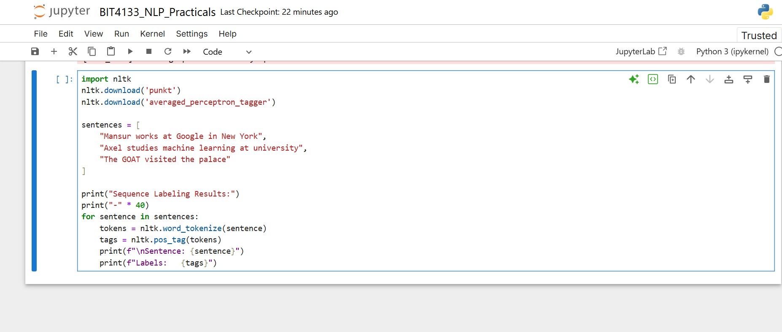
Fig 1: Python code implementing sequence labeling on multiple sentences using NLTK's HMM based POS tagger .

Fig 2: Hidden Markov Model Output
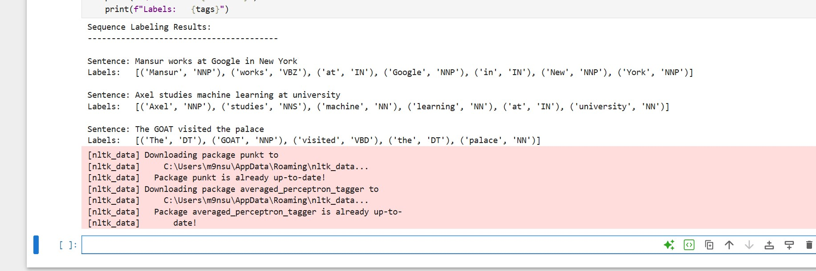
Fig 2: HMM sequence labeling output showing grammatical state predictions for each word across three sentences
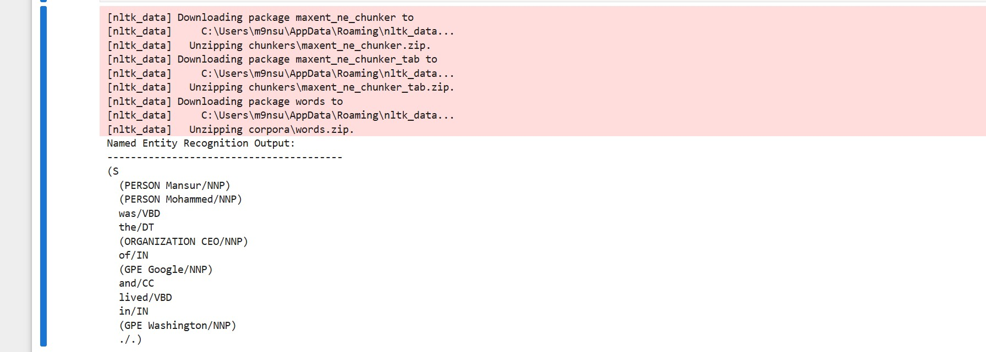

Fig 4: Sentence Labeling Results
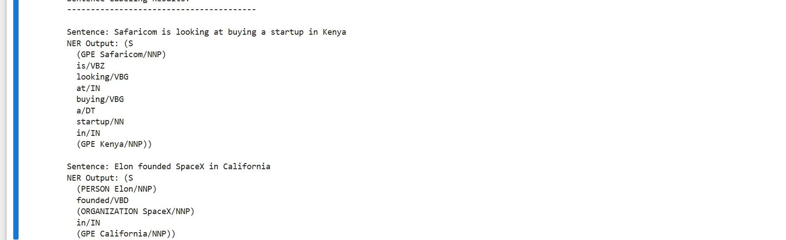
Fig 4: Sentence labeling results showing NER applied to three sentences identifying people , organizations and locations.

Fig 5: Dataset Used for Training or Testing
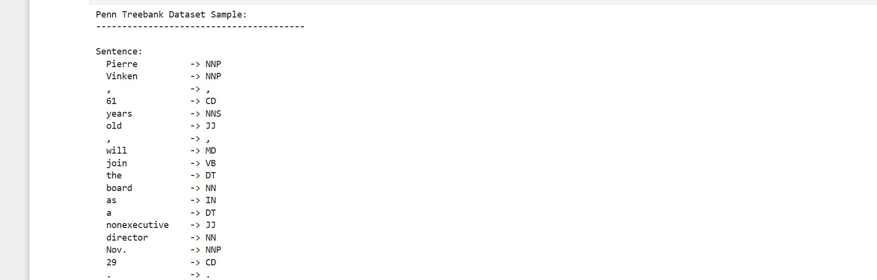
Fig 5: Sample from the Penn Treebank dataset showing word-tag pairs used for training and testing NLP models.
Reflection:I went through Hidden Markov Models and sequence labeling using Python and NLTK I implemented a sequence labeler that applied HMM based POS tagging across multiple sentences. I also ran Named Entity Recognition which successfully identified people, locations and organisations within sentences. The main challenge was downloading the correct NLTK resources for NER chunking as multiple packages were required including maxent_ne_chunker and words before the code would run successfully. The Penn Treebank dataset was used as a reference to get how real annotated training data is structured.
WEEK 4: SYNTACTIC AND SEMANTIC ANALYSIS
Practical Tasks

Fig 1 : Dependency parsing code
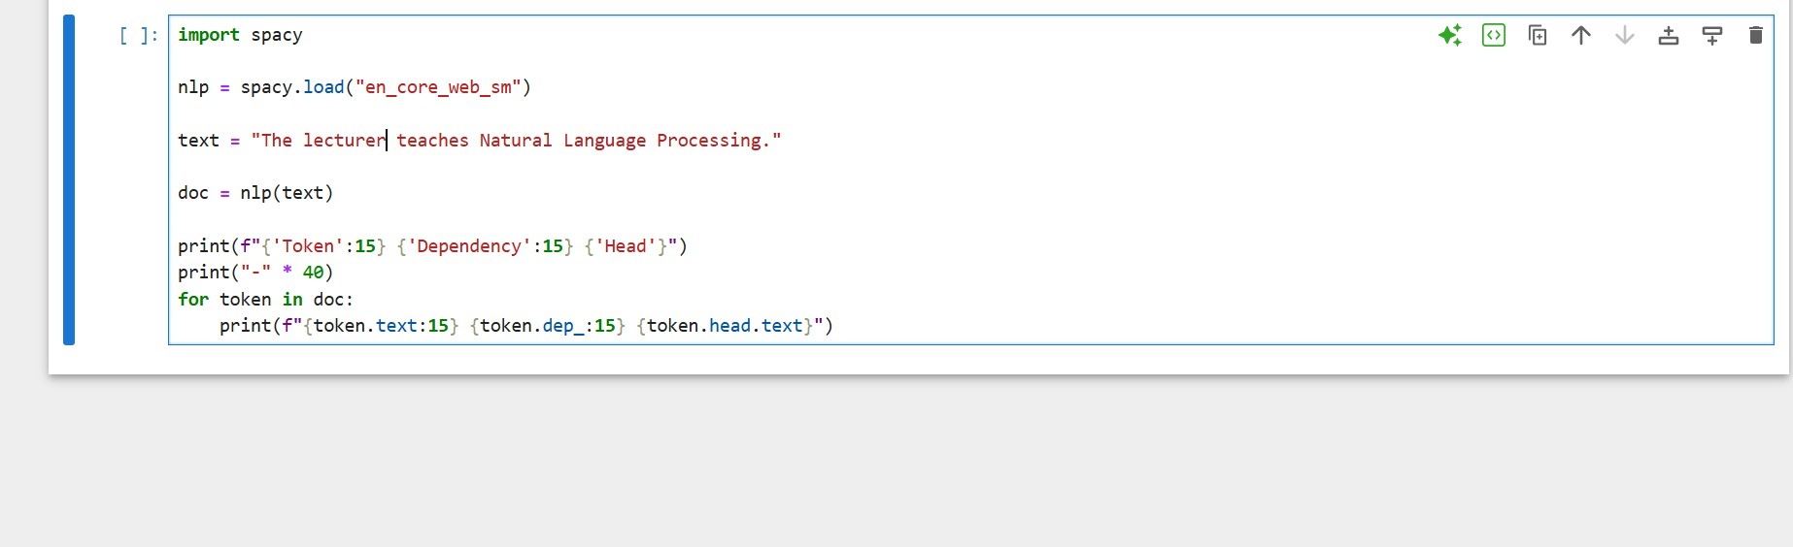
Fig 1: Python code implementing dependency parsing using spaCy's en_core_web_sm language model on a sentence.

Fig 2: Dependency parsing output
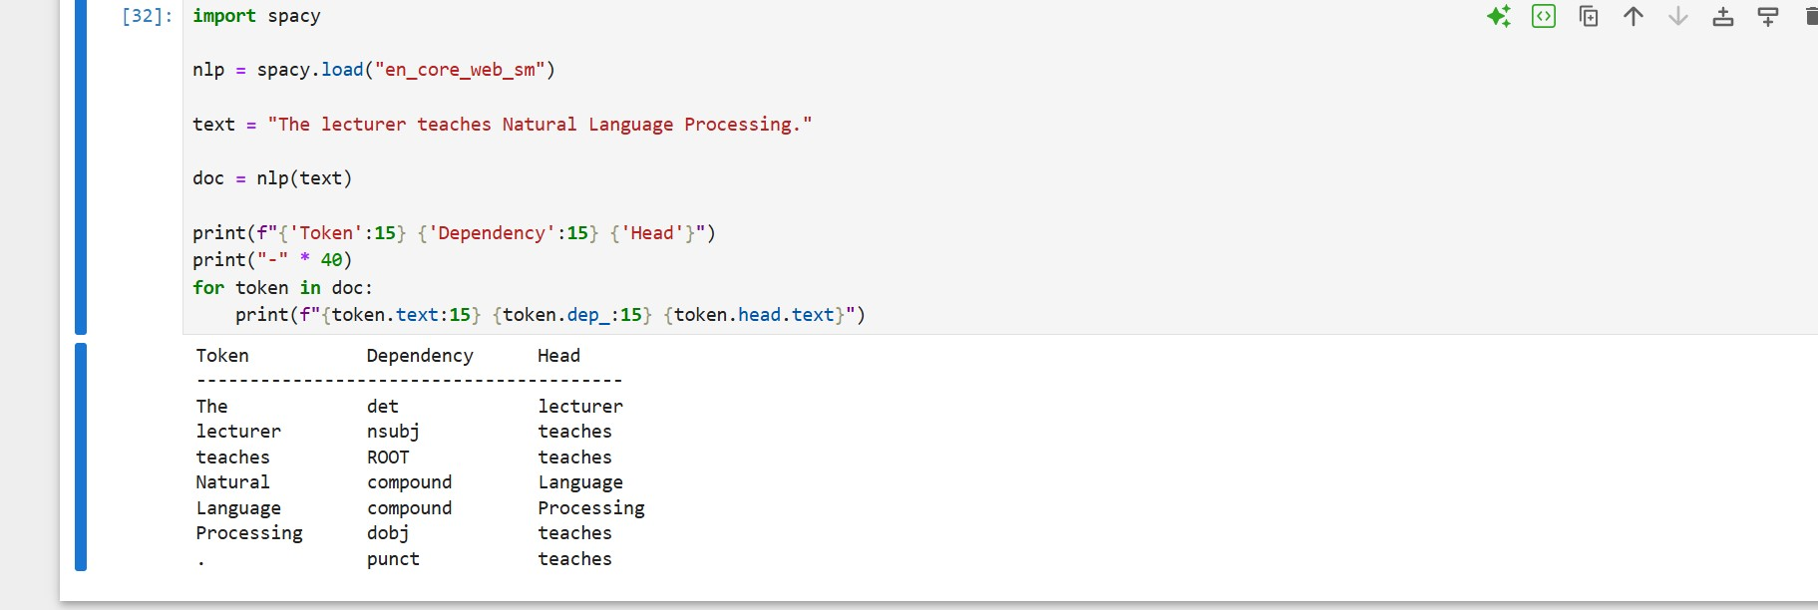
Fig 2: Dependency parsing output showing each token, its grammatical dependency label identifying the root verb, subject and object

Fig 3: V isual dependency tree from displacy
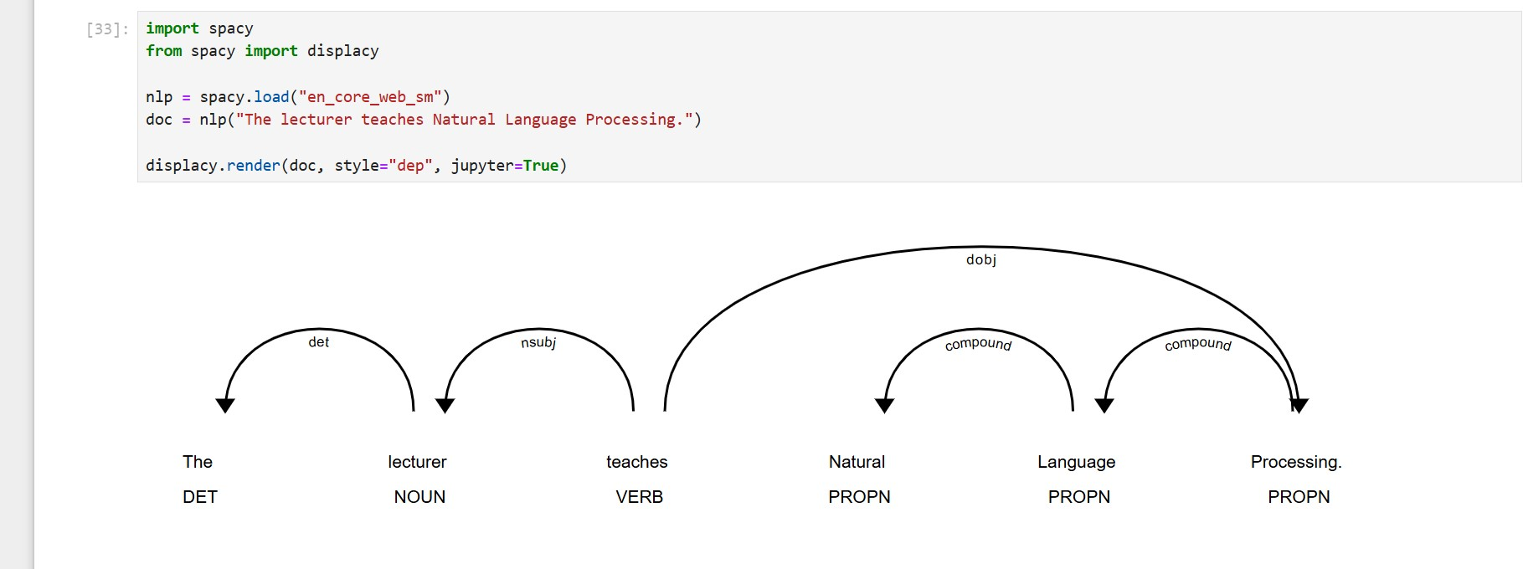
Fig 3: Visual dependency tree generated using spaCy's displacy renderer showing grammatical relationships between words in the sentence

Fig 4: Semantic similarity output
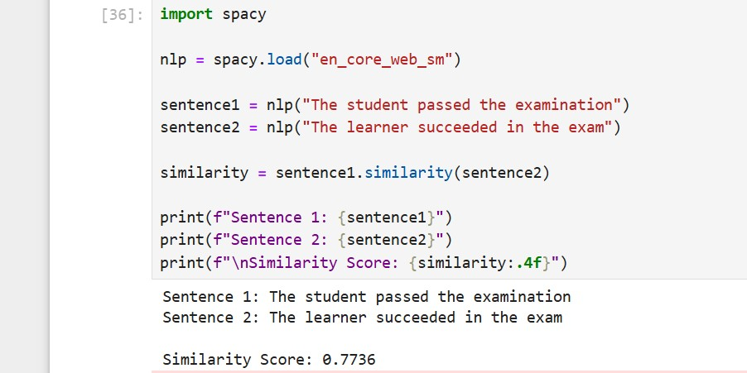
Fig 4: Semantic similarity analysis output comparing two sentences with similar meanings, returning a similarity score of 0.77 out of 1.0.

Fig 5: Semantic Similarity Comparison
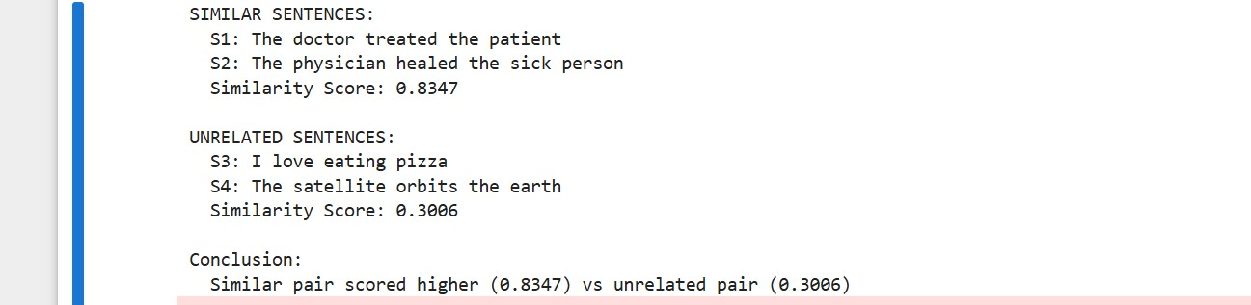
Fig 5: Semantic similarity comparison between a similar sentence pair scoring 0.8 and an unrelated sentence pair scoring 0.3, demonstrating the difference in contextual meaning.

Week Four Assignments
Assignment 1: Dependency Structure Analysis Dependency Tables:
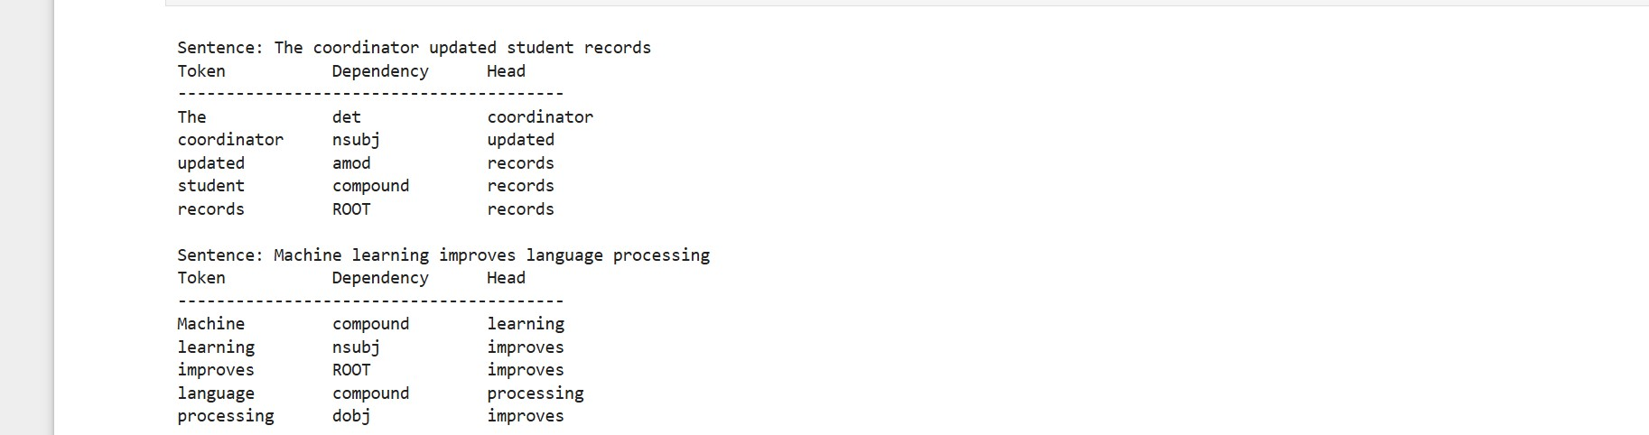
Displacy Trees:
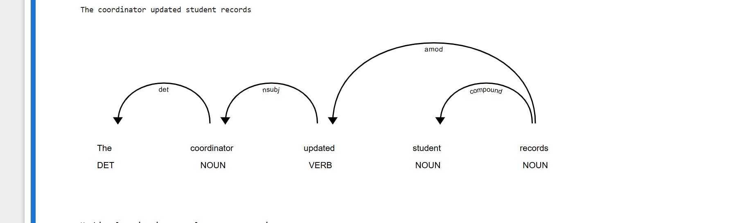
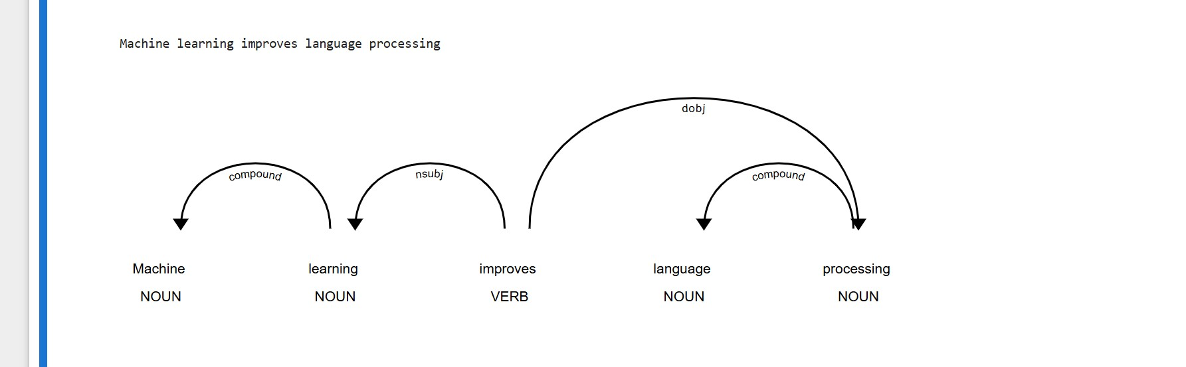

Explanation: In the first sentence 'The administrator updated student records', updated is the root verb, administrator is the subject and records is the object. Student acts as a compound modifier for records. In the second sentence 'Machine learning improves language processing', improves is the root verb, learning is the subject and processing is the object.
Machine and language act as compound modifiers for their respective head words.

Assignment 2 :Semantic Similarity Comparison

Explanation:The similar sentence pair scored 0.8 because both sentences share the same meaning — a medical professional treating a patient — using synonymous words. The unrelated pair scored 0.3 because the sentences share no contextual or semantic connection, one being about food and the other about space. This demonstrates that spaCy's similarity model measures meaning rather than just matching exact words.
Reflection: I got into syntactic and semantic analysis using spaCy. I implemented dependency parsing which identified the root verb, subject and object in sentences and showed how each word grammatically depends on another. The displacy visualization made these relationships clearer to interpret visually. For Assignment 1 I analyzed two sentences and identified their full dependency structures including compound modifiers. I also performed semantic similarity analysis where similar sentences scored around 0.8 while completely unrelated sentences scored as low as 0.3, demonstrating that spaCy measures contextual meaning rather than exact word matching.
WEEK 5 : CAT 1 Prep and Mini NLP projects.
Practical Task 1 :

Fig 1: NLP pipeline
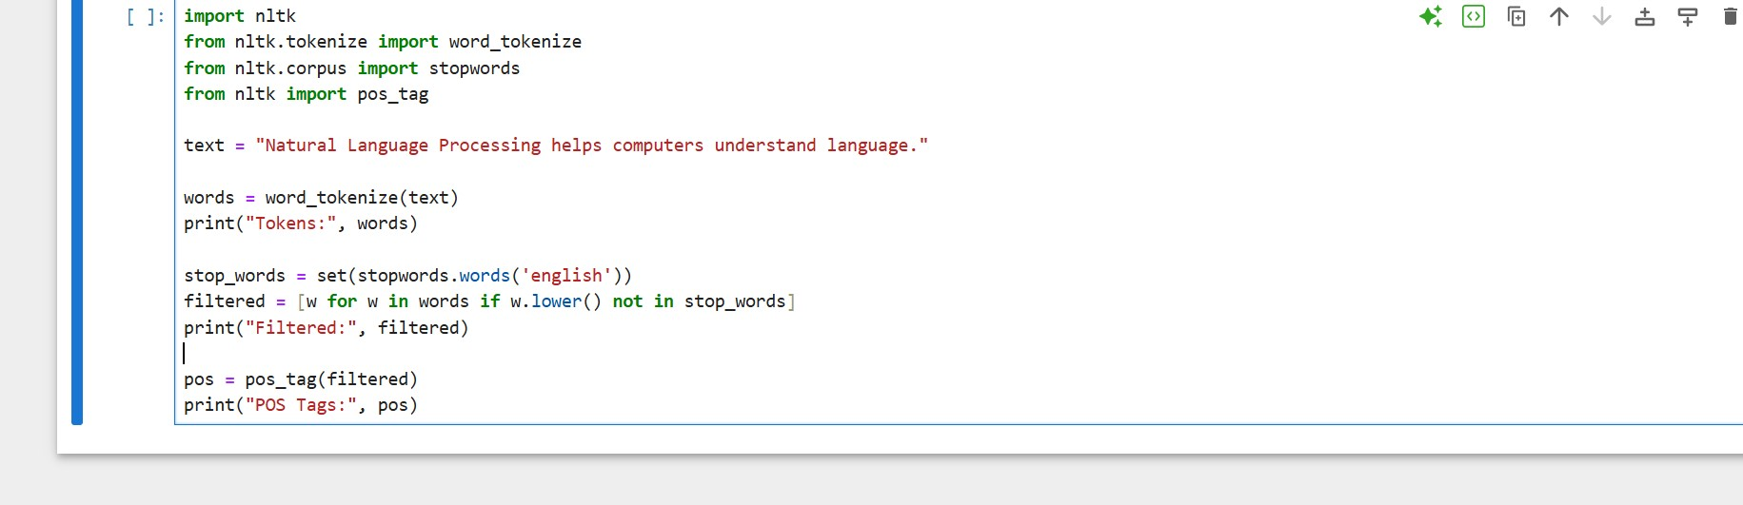
Fig 1: Complete NLP pipeline code combining tokenization, stopword removal and POS tagging

Fig 2:NLP pipeline output
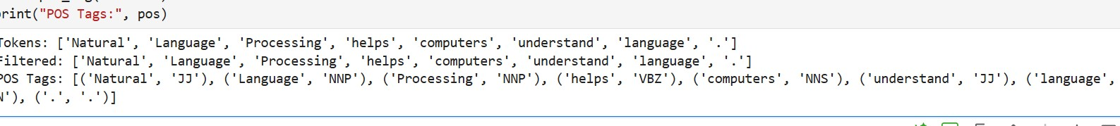
Fig 2: NLP pipeline output showing raw tokens, filtered tokens after stopword removal and final POS tagged words

Fig 3:Rule based Chatbot
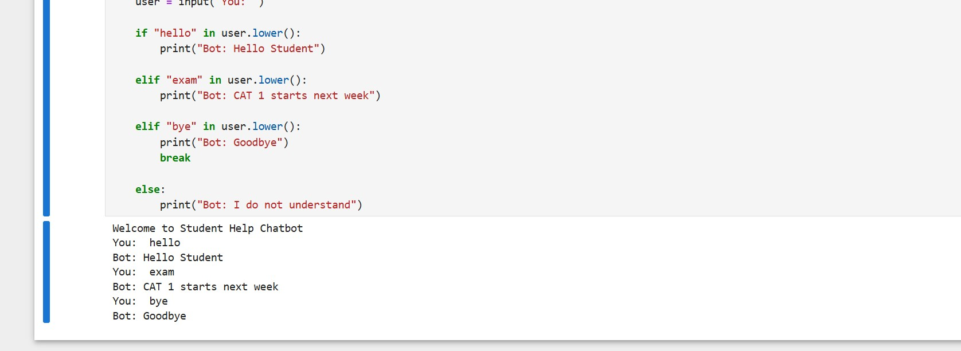
Fig 3: Rule based chatbot interaction demonstrating pattern matching responses to student inputs including greeting, exam query and exit command.

Fig 4: Full mini project chatbot conversation
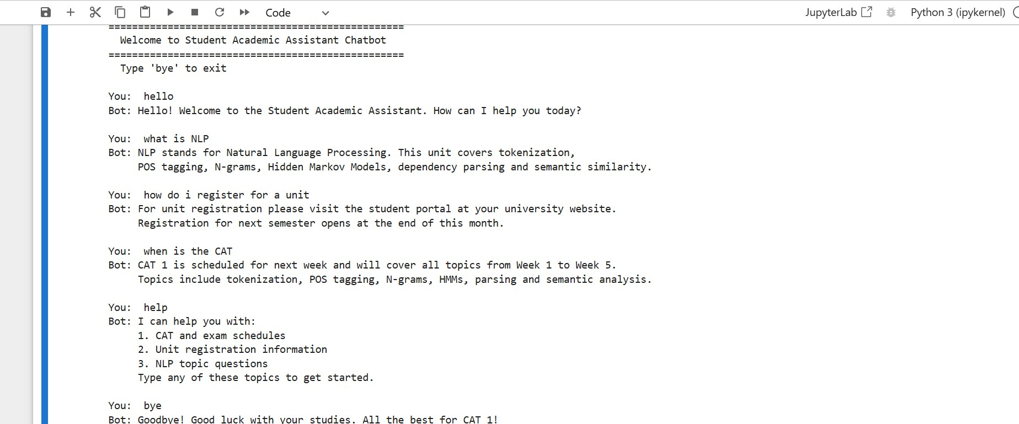
Fig 4: Student Academic Assistant Chatbot full conversation showing responses to greetings, CAT schedule queries, unit registration questions, NLP topic questions and exit command.

Fig 5:Chatbot python source code
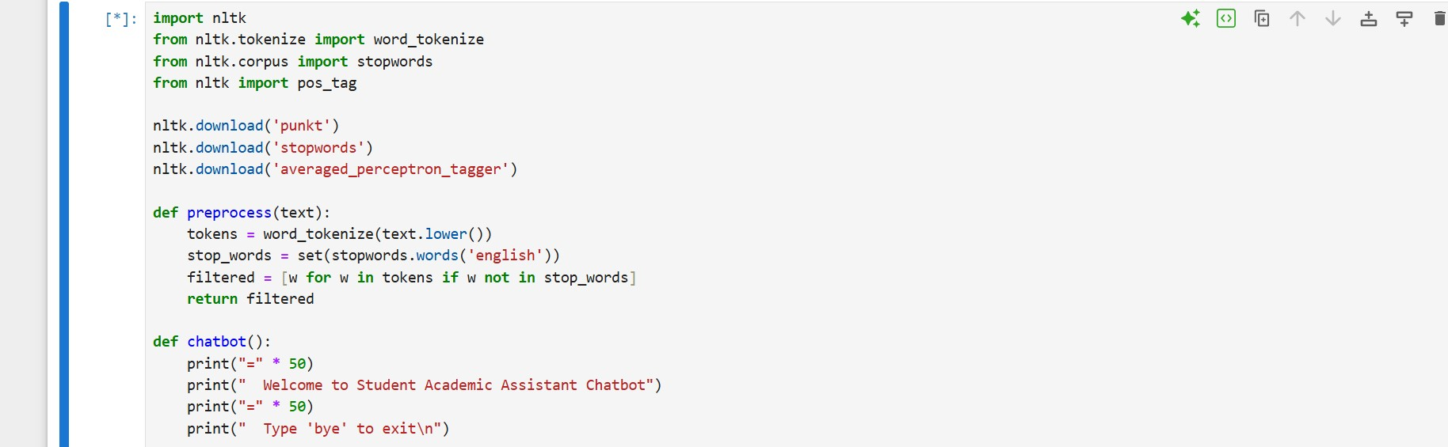
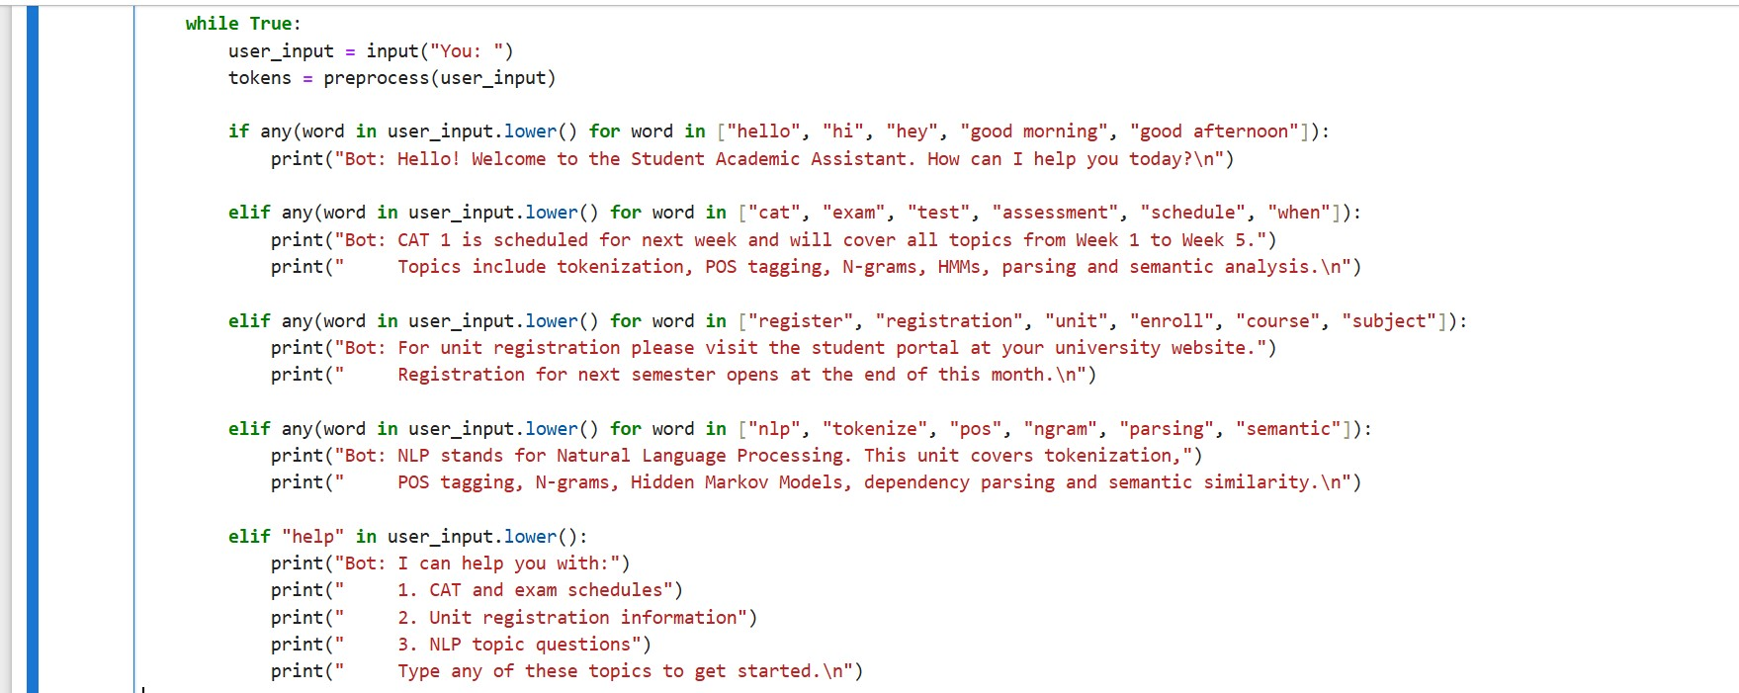
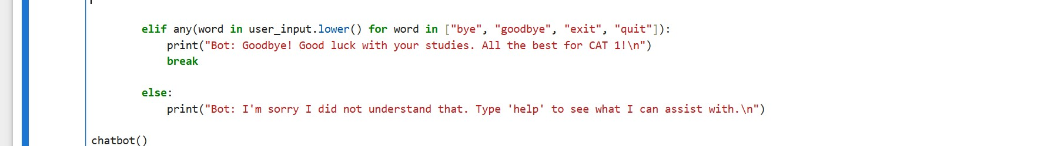
Fig 5:Python source code for the Student Academic Assistant Chatbot showing the full implementation .
Reflection:
I have intergrated all NLP concepts from Weeks 1 to 4 into a complete pipeline and mini project with a full preprocessing pipeline combining tokenization, stopword removal and POS tagging in sequence, observing how raw text is cleaned and analyzed at each stage. I also developed a rule based Student Academic Assistant Chatbot that responds to greetings, CAT schedule queries, unit registration questions and NLP topic questions using pattern matching and NLTK preprocessing.

